Optimal temperature of enzymes present in human body is
A. 27°C
B. 37°C
C. 47°C
D. 30°C
ANSWER: B
Enzyme are sensitive to even a minor change in:
A. Substrate concentration
B. Temperature
C. pH
D. All of these
ANSWER: D
The temperature at which an enzyme shows its highest activity is called:
A. Optimum temperature
B. Prime temperature
C. Maximum temperature
D. Finest temperature
ANSWER: A
Enzymes denature at _____________temperatures so rate falls rapidly.
A. High
B. Medium
C. Low
D. None of these
ANSWER: A
Bacteria living in hot springs may have an optimum temperature of:
A. 10 °C or higher
B. 30 °C or higher
C. 70 °C or higher
D. 80 °C or higher
ANSWER: C
Name the factors, which affect the enzyme activity
A. Temperature
B. pH
C. Atmospheric pressure
D. Both A and B
ANSWER: D
The temperature which causes denaturation of the enzyme is called:
A. Optimum temperature
B. Prime temperature
C. Maximum temperature
D. Finest temperature
ANSWER: C
Enzymes destroyed when proper shape is lost. This is called:
A. Destruction
B. Reformation
C. Denaturation
D. None of these
ANSWER: C
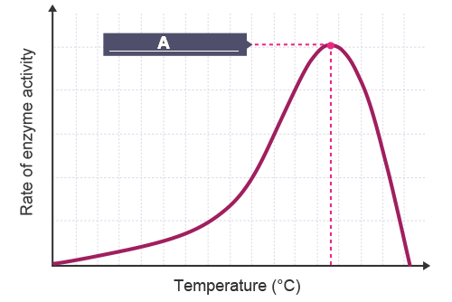
What A represents in the above graph?
A. Optimum temperature
B. Prime temperature
C. Maximum temperature
D. Finest temperature
ANSWER: A
Which graph shows the effect of temperature on enzyme-controlled reactions?
A. 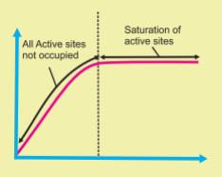
B. 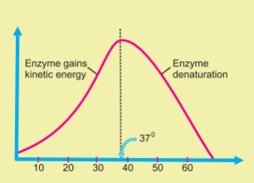
C. 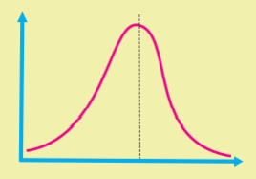
D. None of these
ANSWER: B
Excessive increase in temperature of the medium causes the enzyme molecule to
A. Activate
B. Unaffected
C. Denatured
D. None of these
ANSWER: C
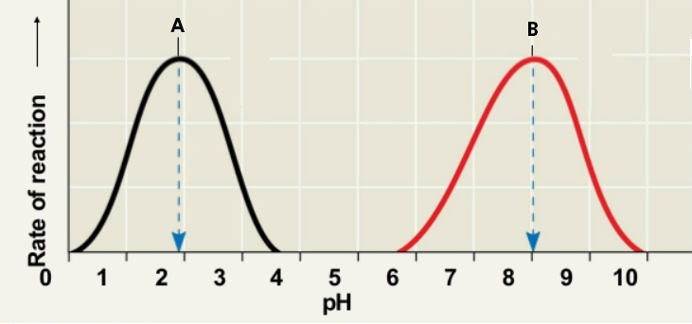
What does A represent in the given graph?
A. Maximum pH for pepsin
B. Optimal pH for pepsin
C. Maximum pH for trypsin
D. Optimal pH for trypsin
ANSWER: B

What does B represent in the given graph?
A. Maximum pH for pepsin
B. Optimal pH for pepsin
C. Maximum pH for trypsin
D. Optimal pH for trypsin
ANSWER: D
Most other enzymes function within a working pH range of about
A. pH 7
B. pH 6-8
C. pH 8-10
D. pH 6-7
ANSWER: B
All enzymes have an ideal pH value, which is called:
A. Optimal pH
B. Zero
C. Maximum pH
D. Minimum pH
ANSWER: A
Papain act in:
A. Acidic medium
B. Neutral medium
C. Alkaline medium
D. Both A and C
ANSWER: D
If the concentration of enzyme is kept constant and amount of substrate is increased a point is reached where increase in substrates concentration does not affect the reaction rate because of
A. Enzymes get denatured at higher substrate conc.
B. Rate of reaction is indirectly proportional to substrate concentration at this point.
C. All the active sites on the enzyme molecule are occupied
D. None of these
ANSWER: C
Which of the following graph represent the relationship between enzyme concentrations and the rate of an enzyme-controlled reaction
A. 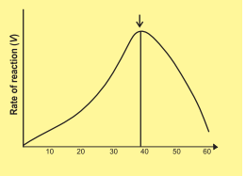
B. 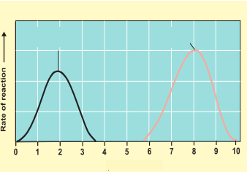
C. 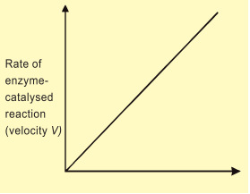
D. 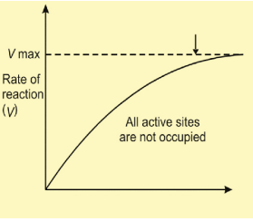
ANSWER: C

Provided that the substrate concentration is maintained at a high level (unlimited availability), and other conditions such as pH and temperature are kept constant, the rate of reaction becomes directly proportional to the
A. Enzyme concentration
B. Reactant percentage
C. Product percentage
D. Active site
ANSWER: A
If there is only one ________in the system it can convert hundreds of substrates into products but it takes more time
A. Reactant
B. Enzyme
C. Allosteric site
D. Non-catalytic site
ANSWER: B
By increasing the concentration of___________, numbers of active sites become more available and the rate of conversion of substrate into product becomes fast
A. Allosteric site
B. Non-catalytic site
C. Enzyme
D. None of these
ANSWER: C
If more substrate to already occurring enzymatic reaction is added more enzyme activity is seen because:
A. There is probably more substrate present than there is enzyme
B. There is probably more enzyme available than there is substrate
C. There is probably more product present than there is either substrate or enzyme
D. The enzyme-substrate complex is probably failing to form during the reaction
ANSWER: B
Enzyme are sensitive to even a minor change in:
A. Substrate concentration
B. Temperature
C. pH
D. All of these
ANSWER: D
If the concentration of enzyme is kept constant and amount of substrate is increased a point is reached where increase in substrates concentration does not affect the reaction rate because of
A. Enzymes get denatured at higher substrate conc.
B. Rate of reaction is indirectly proportional to substrate concentration at this point.
C. All the active sites on the enzyme molecule are occupied.
D. None of these
ANSWER: C
Which of the following graph represents the affect of substrate concentration on the rate of enzyme controlled reaction?
A. 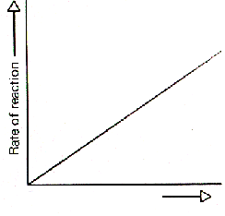
B. 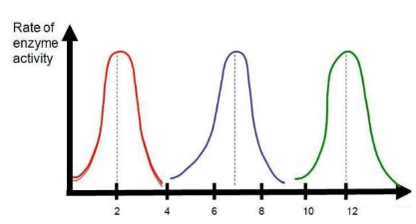
C. 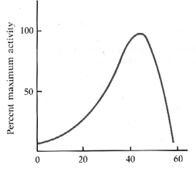
D. 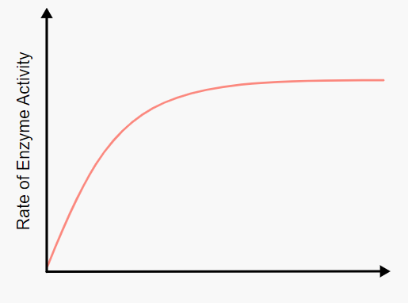
ANSWER: D
When the concentration of substrate increases, the rate of reaction __________ initially
A. Decreases
B. Increases
C. Maintained
D. Disturbed
ANSWER: B
When substrate molecules are greater in number than enzymes, there will be no availability of enzyme ________ for the substrate to combine with
A. Binding sites
B. Active sites
C. Non-catalytic sites
D. Functional sites
ANSWER: B
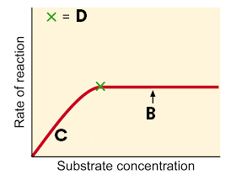
Look at the given graph, what does D represent?
A. Increasing concentration does not affect the reaction rate
B. Point of saturation
C. All active sites are not occupied
D. Optimal concentration
ANSWER: B

Look at the given graph, what does B represent?
A. Increasing concentration does not affect the reaction rate
B. Point of saturation
C. All active sites are not occupied
D. Optimal concentration
ANSWER: A

Look at the given graph, what does C represent?
A. Increasing concentration does not affect the reaction rate
B. Point of saturation
C. All active sites are not occupied
D. Optimal concentration
ANSWER: C

